Assam Tea – Bold, Malty, and World-Renowned
By The Export Express – Premium Tea Exporters from India

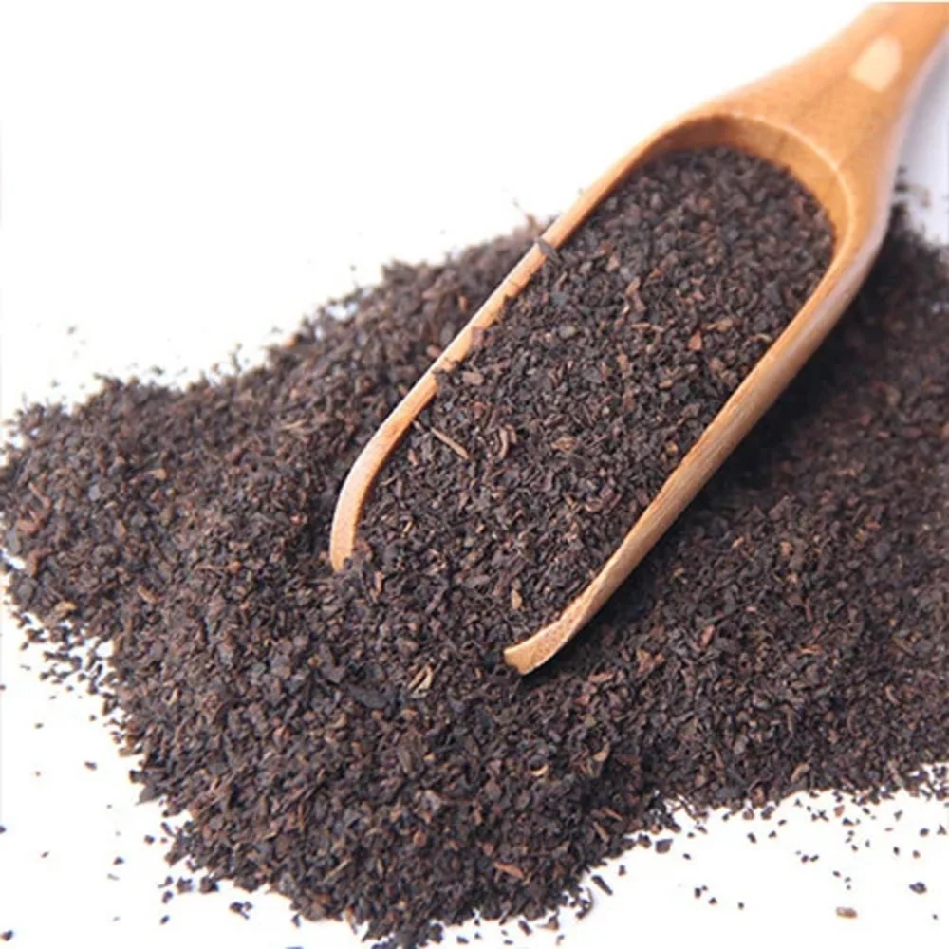

Introduction
Assam Tea stands as one of India’s most globally admired black teas — known for its strong liquor, bright color, and bold malty flavor.
Grown in the fertile Brahmaputra Valley of Assam, this tea’s strength and briskness make it the foundation of countless global blends, from English Breakfast Tea to Masala Chai.
At The Export Express, we supply a complete range of Assam teas — from mass-demand CTC varieties to luxury orthodox long-leaf teas prized by international connoisseurs.

Origin and Growing Region
The Assam region, lying at low altitudes near sea level, experiences heavy rainfall and tropical humidity — perfect for the Camellia sinensis var. assamica plant.
This climate produces teas with robust body, deep color, and natural sweetness, distinguishing Assam from all other Indian teas.
Each leaf carries the essence of its high-grown estates, handpicked and processed using traditional and modern CTC techniques.

The Most In-Demand Type: Assam CTC Tea
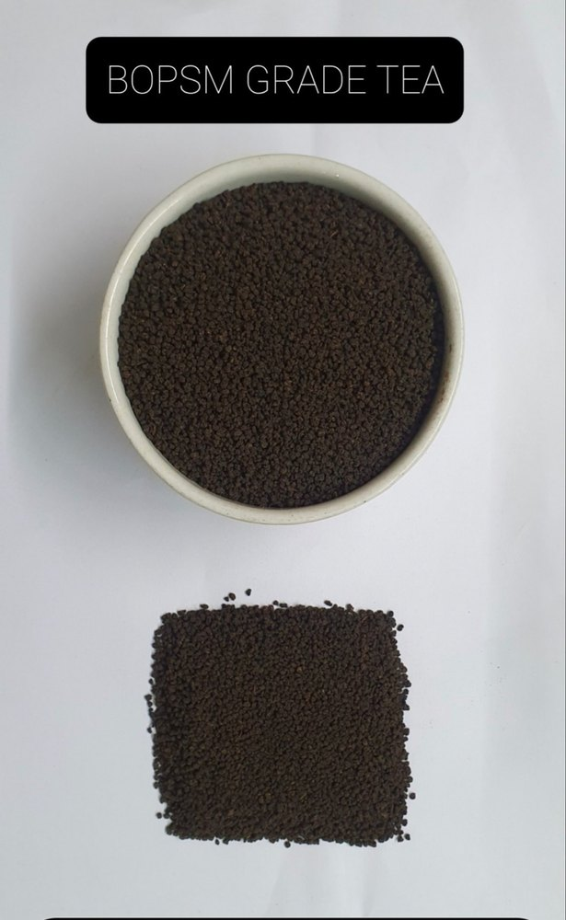
Caption: Assam CTC Tea – Known for its rich color, malty flavor, and strong liquor.

What is CTC Tea?
CTC (Crush–Tear–Curl) tea is mechanically processed to produce uniform granules. It’s the most widely consumed style in both domestic and international markets due to its fast brewing and consistent flavor.

Popular Grades of Assam CTC Tea
Grade | Full Form | Description | Brew Profile | Best Use
BP | Broken Pekoe | Medium-sized granules with brisk flavor | Bright, strong, malty | Everyday blends, tea bags
BOPSM | Broken Orange Pekoe Small | Fine and strong with thick liquor | Deep red, full-bodied | Chai and milk teas
PF | Pekoe Fannings | Smaller particles with quick color release | Dark, intense | Instant teas, catering
PD | Pekoe Dust | Very fine particles | Strongest color and taste | Low-cost blends, mass market
OF | Orange Fannings | Slightly larger than PD | Balanced flavor and aroma | Quick-brew teas
These grades are sorted by leaf size and brew strength, not necessarily quality. All grades maintain Assam’s signature flavor: rich, malty, and refreshing.

Distinctive Features of Assam CTC Tea
- Flavor: Bold, brisk, and malty with a smooth finish.
- Color: Deep copper-red liquor when brewed.
- Aroma: Strong, earthy, and refreshing.
- Shelf Life: 12–24 months under ideal storage.
- Form: Granules for easy infusion and consistent flavor extraction.

Premium and Specialty Assam Teas
While CTC teas dominate global demand, orthodox and handpicked premium Assam teas are prized for their sophistication and unique character.

Orthodox Long Leaf Assam Tea
Crafted using the traditional rolling method, orthodox teas preserve the natural leaf structure, resulting in complex flavor layers — from fruity and floral to chocolaty.
Characteristics:
- Whole and semi-whole leaf appearance
- Bright amber liquor with smooth malty sweetness
- Subtle muscatel aroma reminiscent of fine Darjeeling teas
Best suited for: Gourmet retailers, premium wellness brands, and specialty tea importers.

Golden Tips Assam Tea
One of the rarest and most expensive grades, Golden Tips Tea features golden-colored buds at the leaf tips.
It is known for its rich aroma, smooth mouthfeel, and golden-bronze liquor.
Features:
- Handpicked early-season buds
- Naturally high in antioxidants
- Minimal bitterness, mellow finish
- High visual appeal and export value
Ideal for: Luxury tea markets, boutique gift sets, and export catalogs.
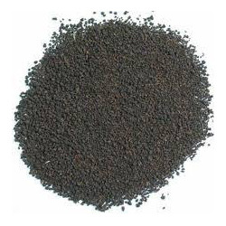

Health Benefits of Assam Tea
- Boosts energy and alertness due to natural caffeine and theanine
- Improves heart health by aiding cholesterol management
- Enhances digestion and metabolism
- Rich in antioxidants that reduce oxidative stress
- Supports mental focus and relieves fatigue

Brewing Guide
Tea Type | Water Temperature | Steeping Time | Ideal Additions
Assam CTC | 95°C | 3–4 minutes | Milk and sugar
Orthodox Assam | 90°C | 3–5 minutes | Lemon or honey
Golden Tips | 85–90°C | 4 minutes | Plain (no milk)
Tip: For stronger flavor, simmer CTC granules in milk and water instead of steeping.

Packaging and Export Information
Attribute | Description
Country of Origin | India (Assam)
Form | Granules / Whole Leaf
Packaging Sizes | 250g, 500g, 1kg, 25kg, 35kg
Shelf Life | 12–24 months
Certifications | FSSAI, ISO, Organic, GMP
Usage | For milk teas, blends, and premium export lines
Storage | Cool, dry place away from moisture

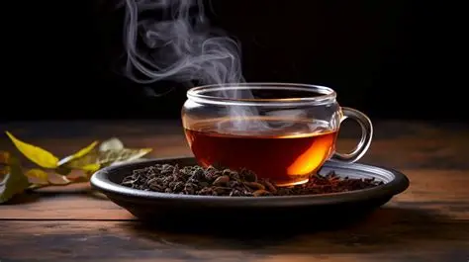

Why Buy Assam Tea from The Export Express
The Export Express provides a complete range of Assam teas for wholesale and private label buyers worldwide.
We specialize in:
- 100% authentic teas sourced from Upper Assam high-grown estates
- Custom packaging – pouches, bulk sacks, and retail boxes
- Private labeling and export documentation support
- Competitive pricing with guaranteed freshness
- Global shipping and quality certifications
Our aim is to connect India’s finest tea gardens to global tea lovers.

Meta Information
Meta Title: Assam Tea – CTC, Orthodox & Golden Tips Varieties | The Export Express
Meta Description: Explore the finest Assam teas including CTC, Orthodox, and Golden Tips. Learn about grades, flavors, and export details from The Export Express – India’s trusted tea exporter.
Keywords: Assam Tea Export India, CTC Assam Tea, Orthodox Assam Tea, Golden Tips Tea, Assam Tea Grades

The Export Express – Delivering India’s Finest Teas to the World.

